Vào đường dẫn C:\Users\nguye\AppData\Local\JetBrains\IdeaIC2023.1

Xóa nội dung bên trong 2 thư mục caches và index

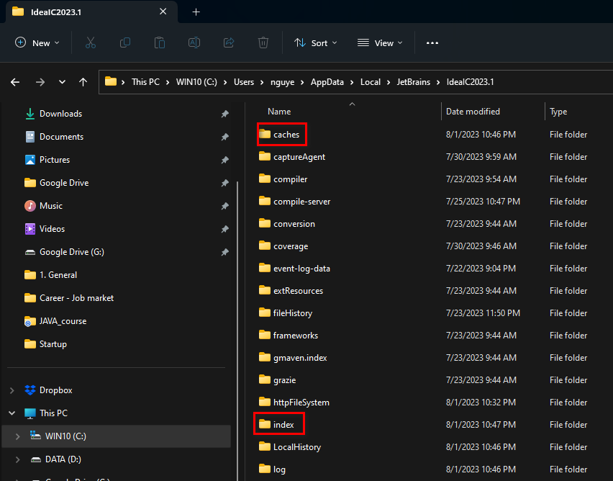

Đã làm thành công 1/8/2023

<https://intellij-support.jetbrains.com/hc/en-us/articles/207241085-Locating-IDE-log-files>

**Locating IDE log files**[**FOLLOW**](https://intellij-support.jetbrains.com/hc/en-us/articles/207241085-Locating-IDE-log-files/subscription.html)

[**JetBrains Team**](https://intellij-support.jetbrains.com/hc/en-us/profiles/1374608081-JetBrains-Team)

Updated July 24, 2023 10:40

The easiest way to find the product log file is the **Help** menu, the item name would depend on the IDE version and OS:

* Show Log in Explorer
* Show Log in Finder
* Show Log in Konqueror/Nautilus
* Reveal Log in Explorer
* Reveal Log in Finder/Finder/Nautilus

[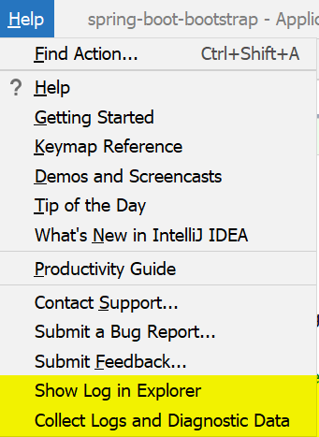](https://i.imgur.com/CyDXFjs.png)

Log file is named **idea.log** and is rotated basing on the file size. When attaching logs to your problem report it's recommended to zip and send several latest log files (idea.log, idea.log.1, idea.log.2, idea.log.3).

You can also use the **Collect Logs and Diagnostic Data**  (**Compress Logs and Show in ...** before 2020.1) action to generate the **.zip** file with all the log files (including the build logs and the [automatic thread dumps](https://intellij-support.jetbrains.com/hc/articles/206544899)).

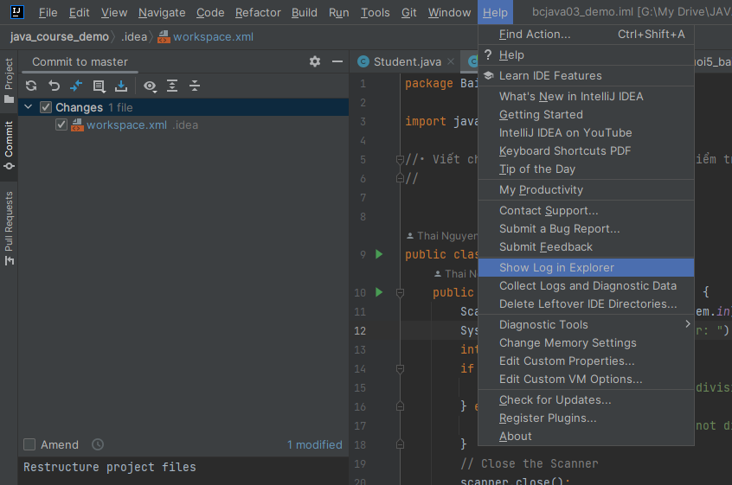

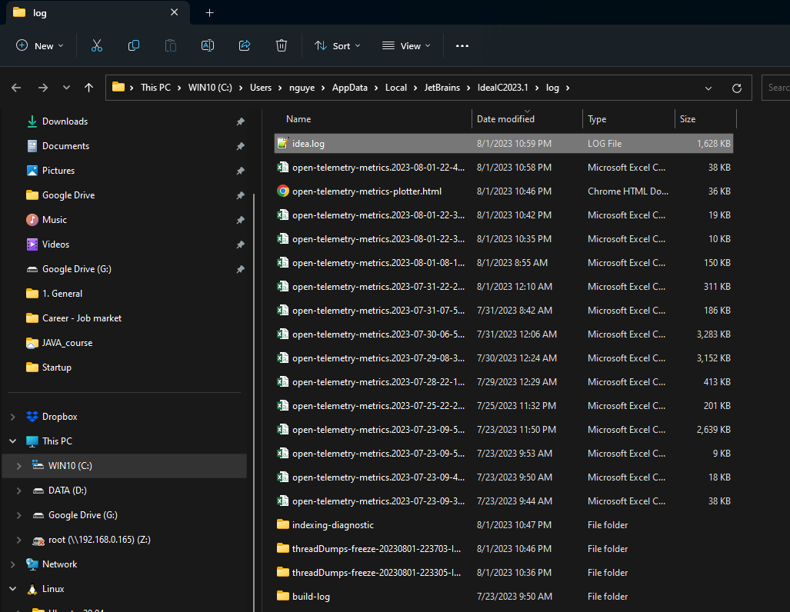

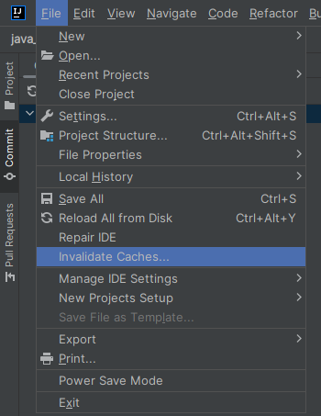

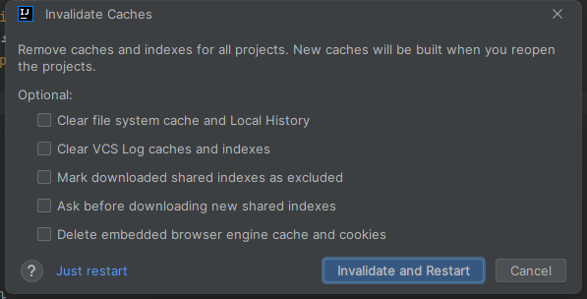

**Windows:**

* Configuration (idea.config.path): %APPDATA%\JetBrains\IdeaIC2023.1
* Plugins (idea.plugins.path): %APPDATA%\JetBrains\IdeaIC2023.1\plugins
* System (idea.system.path): %LOCALAPPDATA%\JetBrains\IdeaIC2023.1
* Logs (idea.log.path): %LOCALAPPDATA%\JetBrains\IdeaIC2023.1\log